Curriculum vitae of Dr B. ANITHA
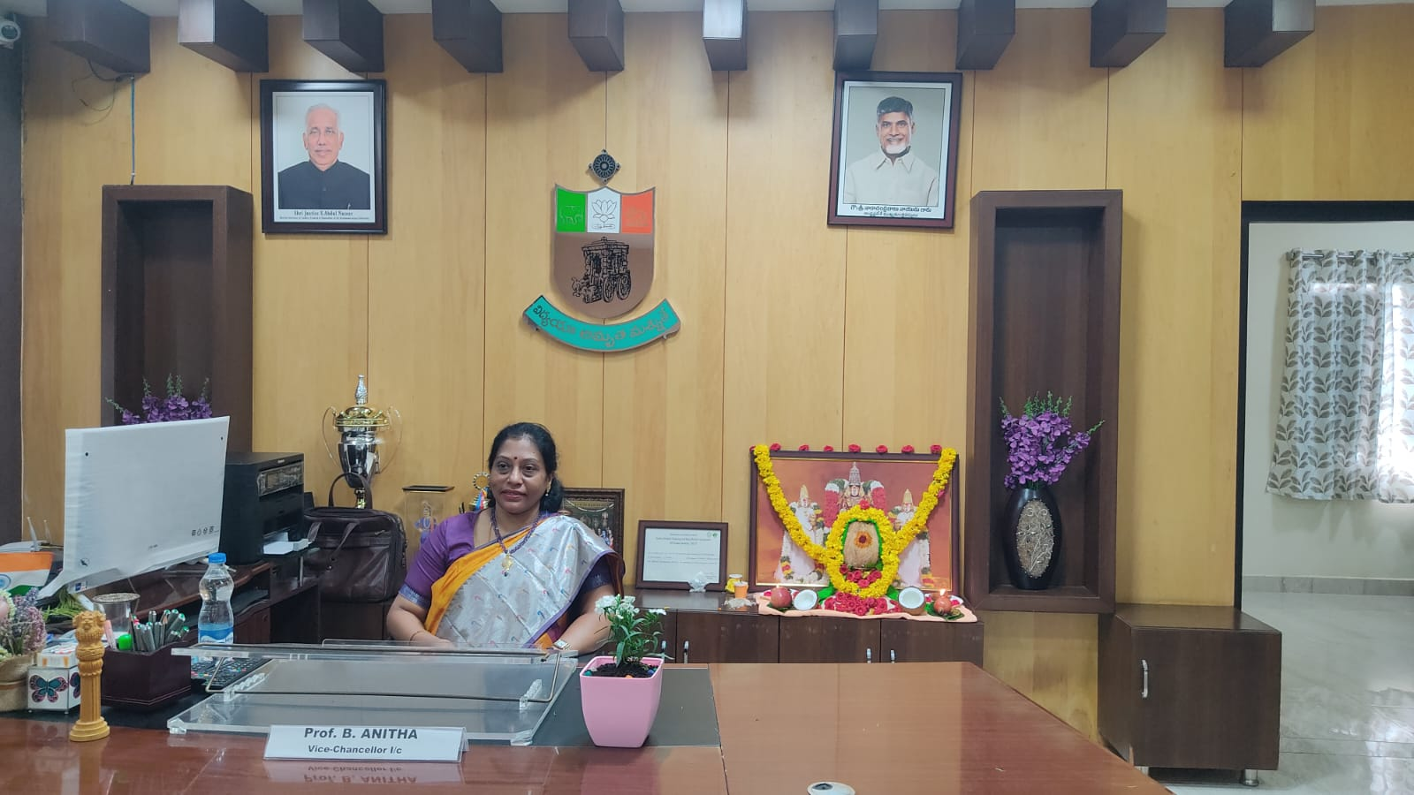
PRESENT POSITION

Vice Chancellor (I/C), Sri Krishnadevaraya University, Professor, S.K. Institute of Management, Sri Krishnadevaraya University. Ananthapuramu-515003, India,
E-mail: anita_skim@yahoo.com

ACADEMIC QUALIFICATIONS

- Ph.D. in Management (1995). With specialization in Human resource management. Thesis, “Quality of Work Life in Commercial Banks – With Special Reference to Andhra Bank and Vysya Bank” Sri Krishnadevraya University, India.
- MBA 1988, Sri Krishnadevaraya University, India.
- B.Com. 1986, S.V. University, Tirupati, India

ACADEMIC EXPERIENCE
- Sri Krishnadevaraya University, India
Professor (2009-present)
- Sri Krishnadevaraya University, India
Associate Professor (1998-2009)
- Sri Krishnadevaraya University, India
Assistant Professor (1989-1998)

DOCTORAL GUIDANCE TOPICS
- Strategic Marketing practices in Indian Television Industry
- Performance Appraisal in defense sector in India.
- Human Resource Management in Air-Conditioner and Refrigeration Industries
- Organizational Change in Select CSOs in India.
- Human Resource Management in Hospitals – A comparative study among Government, Private and Missionary Hospitals in Hyderabad
- Consumer Behavior in two-wheeler industry- with a special reference to 4 Ps among Hero Honda, Bajaj and TVS
- Strategic Management among Mobile Network Providers
- Retention Strategies in select software and BPOs among South Indian Metropolis
- Impact of Team Interventions on Employee performance in Pharmaceutical Industry- With special reference to large and medium companies in Hyderabad.
- Work Life Balance of Women Employees of State Bank of India (with special reference to Rayalaseema region)
- Human Resource Management Practices in Reliance Organized Retail Stores- with reference to Bangalore City
- Retention Strategies in Pharmaceutical Industry- with reference to select 5 Pharmacy Companies in and around AP
- Human Capital Management Practices in Select Retail outlets in Select Cities
- Performance Evaluation of Credit Rating Agencies in India (with special reference to top 5 Credit Rating Agencies)
- A Study on Employee Engagement in Ultra Tech Cement Limited
- Impact of packaging on building a brand image - an empirical study of FMCG in selected cities of Karnataka (Application of kapfrer's brand identity prism)
- Dynamics of work-life balance policies, practices, and employee job performance: A case of select private and public commercial banks in Tanzania.

RESEARCH PROJECT COMPLETED
UGC-Major Research Project on "Consumer Behaviour in Rural and Urban Areas" Amount Rs: 3,25,000, Duration: 1999-2002.

ACADEMIC PUBLICATIONS
Books Published/Authored
- Peer reviewed, Good Beginning for great Success- A Comprehensive Guide to Personality Development, Research India Publications, Delhi, 2018
- Transformation of Global Trade Landscape- Issues, Challenges and Opportunities, Vrinda Publishing House, Hyderabad, 2017
- Technical Communication, CENGAGE Learning, New Delhi, 2013
- Strategic Marketing, Akansha Publishing House, New Delhi, 2013
- Business Communication, CENGAGE Learning, New Delhi, 2012
- Economic Turbulence: Shifts in Business Strategies and Practices, Himalaya Publishing House, Mumbai, 2010
- Quality of Work Life in Commercial Banks, Discovery Publishing House, New Delhi, 1998
- Human Resource Management, Study Material for MBA (Distance Education) S.K.University, Anantapuramuam, 1999.

Articles Published
- HRD at Micro and Macro levels and its future, Understanding HRD, Volume – I, Maharshi Dayanand University Regional Centre, REWARI,1998.
- Quality of Work Life – Basis for HRD, Understanding HRD, Volume – I, Maharshi Dayanand University Regional Centre, REWARI, 1998.
- Stress Management, Organizational Stress, Discovery Publishing House, New Delhi, 1999.
- QWL among women employees of Andhra Bank, Indian Journal of Public Enterprise, Institute of Public Enterprises Research, Allahabad, 2000.
- Gearing up Human Resource for New Millennium, Human Resource Management in the New Millennium, Himalaya Publishing House 2000, pp.3 to 8.
- Human Values, Human Resource Management in the New Millennium, Himalaya Publishing House 2000, pp.58 to 65.
- Ethics and Normative Philosophy, Human Resource Management in the New Millennium, Himalaya Publishing House 2000, pp.78 to 89.
- Manpower Planning: Going Western or Staying Indian? Human Resource Planning, Discovery Publishing House, 2005. pp. 316 to 318.
- Impact of Globalization on Contemporary Manpower Planning in India, Technical Manpower Planning, Discovery Publishing House, 2005. pp. 69 to 84.
- Customer Relationship Management at National Productivity Council, Business Vision, Vol.3 No.1, Jan-Mar 2007.
- Strategic Marketing Practices in the Indian Television Industry, The ICFAI journal of Business Strategy, Vol.III No.4, Dec 2006.
- Cross Cultural Dynamic and Indian Corporate in 21st Century, GITAM Journal of Management Vol.5 No.4 pp169-177 Oct-Dec 2007.
- “Physical Working Conditions in Commercial Banks (an Assessment of Quality of Work Life)”, The Executive Journal, Department of Management Studies, Mahatma Gandhi College, Guntur, Vol.5, No.2, July – December 2006, pp 1-10.
- “Does Performance Appraisal motivate?” Authored by Bommagouni Anitha & P. Murali Krishna, Building Human Competencies & Achieving Highest Human Potential, PNGHRI, Port Moresby, University of Papua New Guinea, 2006, pp 122 to 127.
- Cross Cultural Dynamics and Indian Corporate in 21st Century, Authored by P. Murali Krishna & B. Anitha Kumar, Building Human Competencies & Achieving Highest Human Potential, University of Papua New Guinea, 2006, pp 54 to 60.
- Persuasion of leadership in Retaining the employees, Authored by E. Jalaja&B.Anitha, ‘Innovative Management Strategies’, Edited by D.Pradeep Kumar & N. GangiSetty, Paramount Publishing House, New Delhi, 2012 pp 152 to 154.
- Role of Knowledge Management in Higher Education, Authored by B. Anitha &Varalakshmi, ‘Innovative Management Strategies’, Edited by D. Pradeep Kumar & N. GangiSetty, Paramount Publishing House, New Delhi, 2012 pp 451 to 453.
- Attrition - A Root Cause Analysis, Authored by E. Jalaja&B.Anitha ‘Management Practices in the Global Perspective’, Edited by Y. Subbarayudu, Paramount Publishing House,New Delhi, 2012 pp 127 to 134.
- Women Employee’s Work and Life-Striking the Right Balance, Authored by E. Jalaja& B. Anitha, Management Practices in the Global Perspective, Edited by Y. Subbarayudu, Paramount Publishing House,New Delhi, 2012 pp.151 to 157.
- Influence of employee empowerment in organizations, Authored by D. Varalakshmi, B. Anitha kumar&G.Sarika, Innovative Practices In Management, Edited by K.S. Ramakrishna, Pathap B.N &Suchitra, Himalaya Publishing House, Mumbai, 2012 pp. 185 to 191
- Impact of Quality Circle Intervention on Employee Performance.Authored by D. Varalakshmi, B. Anitha kumar in Journal of Research, Extension and Development, Issn: 2319-1899, 2014, Pp. 114-116.
- Work Life Balance of Bank Employees (A Comparative Study at State Bank of India and Karnataka Bank in Andhra Pradesh State), authored by Sarika G and B. Anitha, International Journal of Political Science, Law and International Relations; ISSN: 2278-8832; ISSN (Online): 2278-8840; Vol- 5, Issue-2, April, 2015; Impact factor (JCC) (2014): 1.6729; Index Copernicus Value(ICV)- 2015: 3.0
- Opportunities and Grand Challenges at Space Technology for Globalized India, authored by G. Sarika and B. Anitha Kumar, ‘Transformation of Global Trade Landscape- Issues, Challenges and Opportunities’, Vrinda Publishing House, HYD, ISBN: 978-93-85518-00-3, pp. 103-108
- Make in India: A Boon or Bane to Globalized India, authored by S. Veeramangala and B. Anita Kumar, ‘Transformation of Global Trade Landscape- Issues, Challenges and Opportunities’, Vrinda Publishing House, HYD, ISBN: 978-93-85518-00-3, pp 61-66
- India’s Bottom of the Pyramid Market: Fortune for MNCs, authored by S. Veeramangala and B. Anitha Kumar, ‘Transformation of Global Trade Landscape- Issues, Challenges and Opportunities’, Vrinda Publishing House, HYD, ISBN: 978-93-85518-00-3, pp 125-132
- A Study on Significance of Travel and Tourism in Andhra Pradesh by D Varalakshmi and B Anitha Kumar, International Journal of Research(IJR), Vol-04, Issue – 14, November 2017 ISSN: 2348-6848
- “Employee Engagement- Factors influencing Employee Engagement”, JETIR, ISSN No 63975, Volume 6 Issue1, January 2019.
- Human Capital Management Practices and Their Impact on Employee Performance in Select Retail Outlets In Select Cities IJMSRR E- ISSN - 2349-6746 ISSN -2349-6738, Feb 2020 (Impact factor 5.442)
- Human Capital Management Practices and Their Impact on Employee Performance in Retail Outlets IJMSRR E- ISSN - 2349-6746 ISSN -2349-6738, Feb 2020 (Impact factor 5.646)
- “Analysis of the consistency of credit ratings in Indian capital markets”, International Journal of Emerging Technologies and Innovative Research (www.jetir.org), ISSN: 2349-5162, Vol.7, Issue 10, page no. 328-337, October-2020.
- “Performance Analysis of credit rating consistency in capital markets” International Journal of Emerging Technologies and Innovative Research (www.jetir.org), ISSN: 2349-5162, Vol.7, Issue 10, page no.590-595, September-2020.
- “A study of employee engagement in Ultra Tech Cement Limited-South Cluster” JRYIT, ISSN No 63975, Volume 7 Issue 10, Oct 2020, 10-16 (Impact factor 7.95)
- Role of packaging on consumer brand preference of FMCG products. NIU International Journal of Human Rights ISSN: 2394 – 0298 Volume 8(XXII), 2021.
- Impact of visual elements of packaging on consumer buying behaviour of FMCG products. ANVESAK ISSN: 0378 – 4568 Vol. 51, No.2 (V) July – December 2021
- Flexible Work Arrangements, Leave Provisions, and Employee Job Performance in Banking sector. Journal of Positive School Psychology http://journalppw.com 2022, Vol. 6, No. 5, 5596 – 5612.
- Nexus between workplace health and employee wellness programs and employee performance. GAP interdisciplinarities, A Global Journal of Interdisciplinary Studies (ISSN – 2581-5628) Volume - V Issue II April – June 2022.
- The role of supervisor work-life support on the correlation between work autonomy, workload and performance: perspective from Tanzania banking employees. Future Business Journal, 8(1), 1-16, ISSN No. 2314-7210 August 2022.
- The effects of Emotional intelligence on managers job performance in India banks in Dogo Rang Sang ISSN 2347-7180 with IF=5.127 Vol. 13, Issue 4 no. 02, April 2023 Page No 97-105.
- The role of personal excellence and emotional intelligence in work life balance in Dogo Rang Sang ISSN 2347-7180 with IF=5.127 Vol.13 Issue 6 No 14 June 2023 Page No 26-32.
- Emotional intelligence’s role in banking industry conflict resolution in Shodhak. ISSN 302-9832 with IF 7.75 volume 53 issue 02 No 7 May-August 2023 page No 111-119.

PAPER PRESENTATIONS (INCLUDING PRESENTATIONS BY CO-AUTHORS)
- Personnel Managers’ Concord organized by Sri Krishnadevaraya Institute of Management, S.K. University, Ananthapuramu during April 8 – 9, 1990.
- Seminar on Small Scale Industry organized by Dept. of Commerce, S.K.University, Ananthapuramu during March 23 – 25, 1994.
- Workshop on ‘Case Teaching and Case Writing’ at IIM, Bangalore, organized by Association of Indian Management Schools during June 25-29, 1990.
- UGC National Seminar on Corporate Ethics organized by PG Department of Commerce and Management Studies, TJPS College, Guntur during Dec 12 – 14,1997.
- UGC National Seminar on Risk Management as Modern Welfare Measure in India organized by Sri Krishnadevaraya Institute of Management, S.K. University, Ananthapuramu during March 21 – 22, 1998.
- National Seminar on Indian Ethos in Management organized by the School of Management Studies, Chaitanya Bharati Institute of Technology, Hyderabad during November 6 – 7, 1998.
- All India Commerce Congress organized by the Kerala Commerce Association at Trissure during January 18 – 20, 1999.
- National Seminar on ‘Technical Manpower Planning – Issues and Concerns’ organized by Nodel Centre, NTMIS, IAMR, New Delhi, held at JNTU, Hyderabad during September 5 -7, 2004.
- Workshop on Women Entrepreneurs – Concerns organized by the Department of Management Studies, Mahila University, Tirupati during February 8 – 10, 2007.
- Presented a paper on, “India's bottom of the pyramid market: fortune for MNCs" at UGC sponsored National Seminar on Transformation of Global Trade Landscape- Issues, Challenges & Opportunities at Sri Krishnadevaraya Institute of Management, S K University Ananthapuramu, on 27-28 February 2017.
- Presented a paper on, “Make in India: A Boon or Bane to Globalized India" at UGC sponsored National Seminar on Transformation of Global Trade Landscape- Issues, Challenges & Opportunities at Sri Krishnadevaraya Institute of Management, S K University Ananthapuramu, on 27-28 February 2017.
- Presented a paper on, “Managing people, Planet and profit in Covid World.” Organized on 20-21 December 2021. And has been awarded for best paper titled Work-Life Balance Challenges and Strategies During Covid 19: Lessons from Commercial Banks Employees in Tanzania.
- Presented a paper on, “Work-Life Balance Practices: Work autonomy and workload as predictors of bank employee job performance in Tanzania” at 11 th international conference on multidisciplinary research practices in Humanities, Business management, social science and Education (ICMRP 2022) on 28-29 January 2022.
- Presented a paper on “opportunities and challenges for employee engagement in the digital era” at online national conference on Role of digital platforms in corporate development and management – (RDPCDM) organized by S.E.A. College of Engineering and Technology, Bangalore.

REFRESHER COURSES ATTENDED
- Refresher Course in Teaching Methods of Economics, Dept. of Economics, S.K. University, Ananthapuramu from 6-11-1994 to 27-11-1994.
- New Trends in Business and Commerce and its applications, Dept. of Commerce and Management, Mysore from 25-4-1997 to 15-5-1997.
- Teaching of Commerce: New Approaches, Dept. of Commerce, S.K. University, Ananthapuramu from 7-11-2001 to 27-11-2001.
AWARDS
- Distinguished Woman Award for research work in Human Resource area of Management by Venus International Women Awards Foundation for 2019.

OTHER PROFESSIONAL ACTIVITIES/INSTITUTIONAL SERVICE
- Worked as Additional warden for 3 Women’s hostels, SK University.
- Worked as Director, Centre for Women Studies, SK University.
- Worked in various administrative committees, SK University.
- Worked as Head of the Department of SKIM from 2020-2022.
- Working as Chairman person Board of Studies from Sept. 2021 to 2024.
- Worked as Additional Warden, S.K. University Women’s Hostel 2005-06.
- As a Trainer, Syndicate Bank Executives, Ananthapuramu.
- As a patron “Inspirer” to bring parents, teachers and School Managements together to improve the quality of Education.
- Worked as Secretary “Parent – Teacher Association” Kendraiya Vidyalaya, Ananthapuramu.

WORKSHOPS/SEMINARS ORGANIZED
- National Seminar on ‘Global Economic Turbulence- Recrafting HR Strategies ‘in January 2009.
- International Conference on ‘Economic Turbulence: Shifts in Business Strategies and Practices’ in July 2009.
- Workshop on ‘Gender Sensitivity’, SK University in March 2010.
- National Seminar on ‘Transformation of Global Trade Landscape- Issues, Challenges and Opportunities ‘in February 2017.
- National Webinar on ‘NEP-2020: Challenges in Implementation’ in November, 2020.
PROFESSIONAL ASSOCIATION MEMBERSHIPS
- Life Member of Indian Institute of Public Administration
- Life Member of the National HRD Network. Hyderabad
- Member of S K University Teachers’ Association 1998-99
- Member of MTC (Management Teachers Consortium)
- Member in Editorial Review Board in Adarsh Business Review.



(B. ANITHA)

